A507-Mex-Veracruz-Nopaloa-Smiling Figure-Standing-Terra cotta-600-800 CE

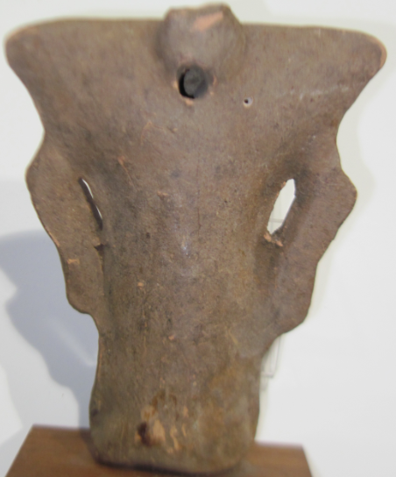

Figs. 1-2. Mex-Veracruz-Nopaloa-Smiling Figure-Standing-Terra cotta-600-800 CE

**Case No.: 10**

**Accession No.: A507**

**Formal Label:** Mex-Veracruz-Nopaloa-Smiling Figure-Standing-Terra cotta-600-800 CE

**Display Description:**

Classic Veracruz culture 600-800 CE flourished in the north and central areas of Veracruz where Nopaloa, and Remojadas, were two important ceramics centers. This smiling figure (or “sonriente” in Spanish) is one of the most fascinating ceramics of Mesoamerica that was produced in south-central Veracruz in the towns of Nopaloa, and Remojadas. The smiling expression of these figure that remains enigmatic suggests a background story that modern archaeology has not recovered. The present male figure wears a tunic with a beaded necklace and is holding with both hands a large felt? headdress, which is adorned with two spools at both upper corners and a beaded border around the face. The verso of the figurine is blank.  
  
Sonrientes like this one were unable to stand on their own, so when they were interred with the deceased they were positioned in an upright position being supported by human skulls and disarticulated bones in secondary burials which has been discovered at the Veracruz site of El Zapotal. The clothing that is represented by this figurine cannot be identified with surety, but the lack of designs on the body covering suggests that what is identified is cotton cloth without design. Mention has been made of the headdress and by virtue of the figure having to hold it in place with both hands, this suggest that it was of substantial weight. White its purpose is unknown it might be surmised that it is associated with the smiling visage. The headdress is a source of mirth or accomplishment.  
 In 1952 Alfonso Medellín Zenil excavated the first Sonrientes and fragments from Veracruz the environs of ceremonial centers where they may have served some ritual function and were discarded. But most Sonrientes lack information concerning their original context, limiting the ability to understand their purpose and meaning.   
  
 The gender of Sonrientes are most often male with loincloths or with exposed genitalia. Some, however, wear skirts and skirts are usually worn by women, although in Mesoamerica there are exceptions. This is complicated by the fact that artists depict female figures in Veracruz art as wearing a huipil, a garment that completely covers the upper body. The disproportionately large heads of Sonrientes may, additionally, indicate dwarfism or perhaps, mythical spiritual beings.

This last suggestion may be supported by the 1970’s find of a cache of Sonrientes at Mound 2 of the primary and secondary burials at El Zapotal together with life-sized terracotta sculpture and murals adorning a U-shaped banquette centering on the monumental clay sculpture of a skeletal Death God.

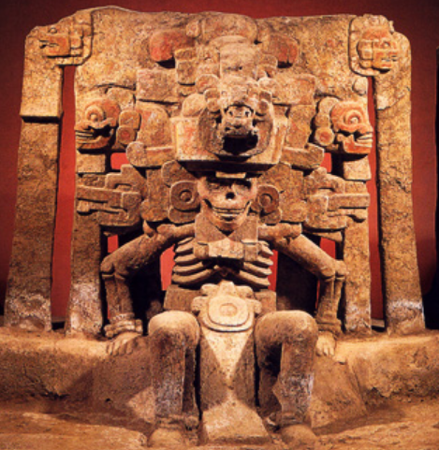

Clay sculpture of Mictantecutli, God of Death, after [HJPD](https://commons.wikimedia.org/wiki/User:HJPD). Left as found. Right as reconstructed.After https://web.archive.org/web/20120503115149im_/http://portal.veracruz.gob.mx/pls/portal/docs/PAGE/VERACRUZTURISMO/IMGV2/IMAGENESBOLETIN09/MICTLANTECUHTLI%20EL%20ZAPOTAL.JPG

Large ceramic pieces were found including the monumental Mictlantecuhtli sculpture, God of death. Mictlantecuhtli also displays a smiling visage which suggests an unsettling answer to its meaning, and that is the smile mirrors the need of Mictlantecuhtli to have souls to feed his hunger. The Sonrientes may just be his emissaries that are placed with the deceased on behalf of Mictlantecuhtli. The ossuary composed of hundreds of Sonrientes are the attendants of death.

Additional attendants are pictured in the wall paintings. Among these are small dwarf-like figures which may represent an earlier version of the Sonrientes or the chaneques of Mexican folklore whom the Mixe-Zoque peoples of southern Veracruz believe serve Chane, the god of the underworld. Cherra Wyllie argues that the Sonrientes placed in the burials below Mound 2 may also represent the chaneques, placed there to attend or guard the human remains as the chaneques are depicted in the paintings to attend the death deity.

**LC Classification: F1219.1.v47**

**Date or Time Horizon:** 600-800 CE

**Geographical Area:**

**Map:**

* 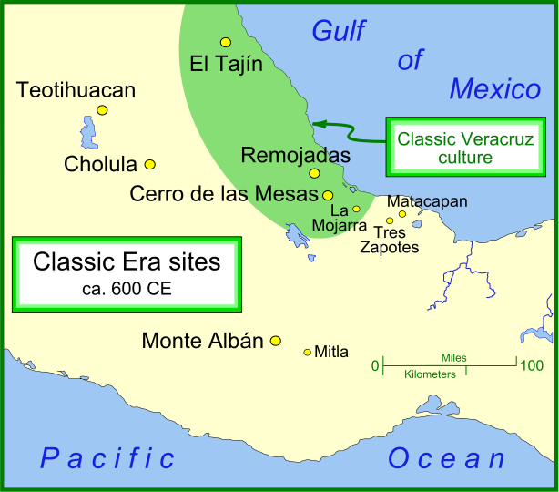
* By Madman2001 - Own work, CC BY-SA 3.0, <https://commons.wikimedia.org/w/index.php?curid=18422641>

**GPS coordinates:** [20°26′53.01″N 97°22′41.67″W](https://tools.wmflabs.org/geohack/geohack.php?pagename=El_Taj%C3%ADn&params=20_26_53.01_N_97_22_41.67_W_type:landmark)

**Cultural Affiliation:** [Totonac](https://en.wikipedia.org/wiki/Totonac)

**Media: ceramic**

**Dimensions:**

**Weight:**

**Condition:**

**Provenance:**

**Discussion:**

**References:**

Heyden, Doris. “Nueva interpretación de las figuras sonrientes, senalada por las fuentes históricas,” Tlalocan, Revista de Fuente para el Conocimiento de las Culturas Indígenas de México, VI:2, Mexico: 1970.   
  
Medillín Zenil, Alfonso. Cerámicas del Totonacapan. Xalapa: Universidad Veracruzana, Instituto de Antropología, 1960.   
  
Medellín Zenil, Alfonso. Nopiloa. Xalapa: Universidad Veracruzana, 1987.   
  
Medellín Zenil, Alfonso, and Frederick A. Peterson. “A Smiling Head Complex from Central Veracruz, Mexico." American Antiquity, Vol. 20, no. 2, pp. 162-169. 1954.   
  
Newton, Douglas. Masterpieces of Primitive Art: The Nelson A. Rockefeller Collection. New York: Alfred A. Knopf, 1978, p. 135.   
  
Nicholson, H.B. et al. Ancient Art of Veracruz. Ethnic Arts Council of Los Angeles, 1971.   
  
Wyllie, Cherra. “The Mural Paintings of El Zapotal, Veracruz, Mexico." Ancient Mesoamerica, 21 (2010), pp. 209-227.   
  
Wyllie, Cherra.” Las Figurellas del Clásico en Veracruz: Reconcideraciones." In Arqueología de la Costa del Golfo. Lourdes Budar, Marciel Liventer, and Sara Ladrón de Guevarra, eds. Xalapa: Universidad Veracruzana, 2017. pp. 161-178.